PROBLEM STATEMENT: 1

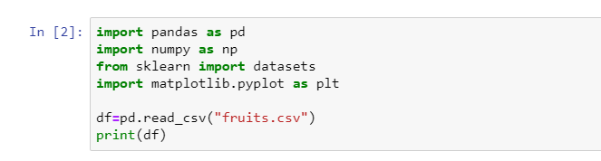

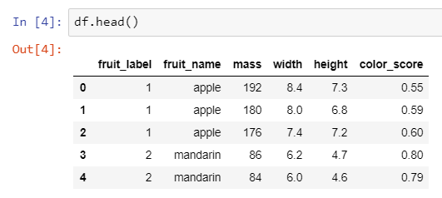

We have loaded our dataset, now we will check its first five rows to check how our data looks and to see which features our data have.

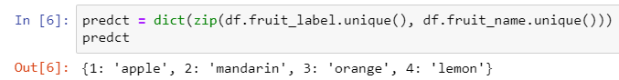

Our dataset has seven columns containing the information about fruits. There are four fruits in our dataset. Every fruit is described with four features 1. Mass of the fruit 2. Width of the fruit 3. Height of the fruit 4. Color score of fruit. Now we check how many fruits are present in our data.

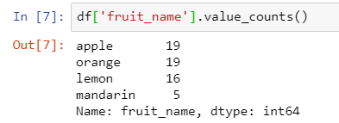

We have seen that the dataset contains four unique fruits. Here we have Apple with 19 entries, Orange with 19 entries, Lemon with 16 entries and mandarin with 5 entries.

Now we will store all unique data on four different dataframes.

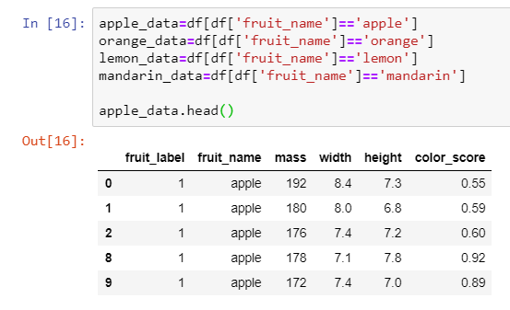

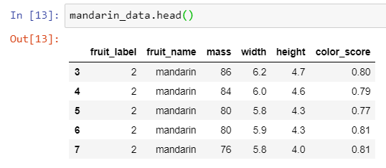

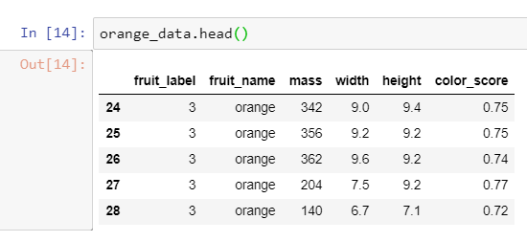

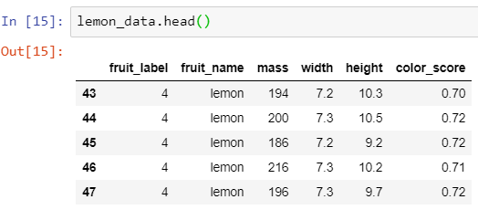

By looking above data, it is shown that for every fruit there is a fruit_label. For apple it is 1, for mandarin it is 2, for orange it is 3 and for lemon it is 4. Now we will visualize this data on plots for further exploration.

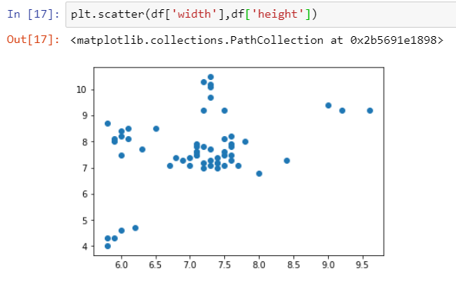

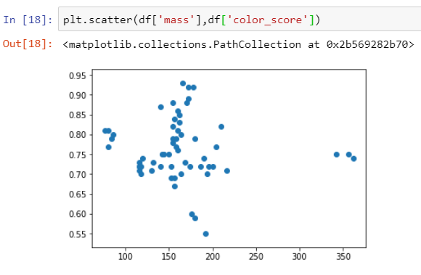

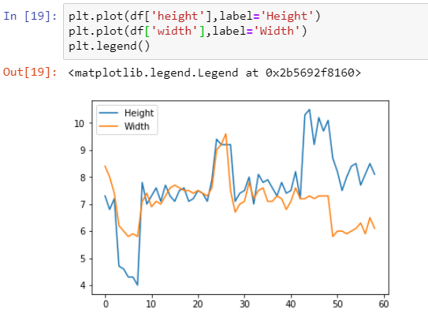

Now we will use K-Nearest Neighbors classifier to predict a new record on the basis of this data. For this we will aplit this dataset into test and train sets. First we will import sklearn library for our model.

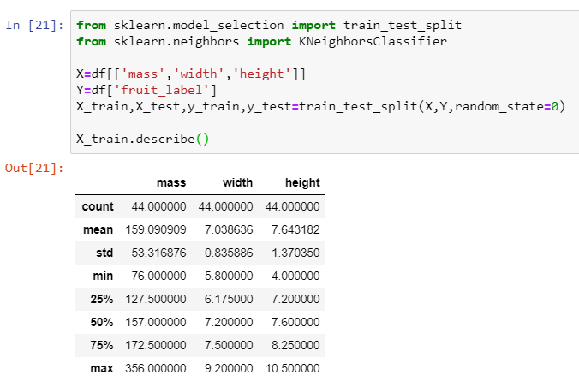

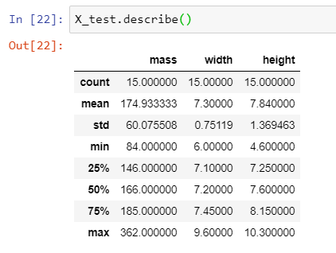

Now we will create a KNN classifier for making predictions.

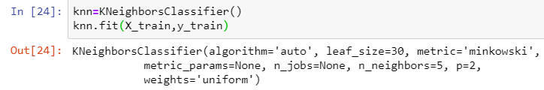

We can check the accuracy of our classifier.

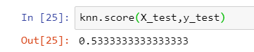

Now we can make predictions with new data as following:

